**Attriation day 12 Assignment**

Columns present in data set

Index(['Age', 'Attrition', 'BusinessTravel', 'Department', 'DistanceFromHome',

'Education', 'EducationField', 'EmployeeCount', 'EmployeeID', 'Gender',

'JobLevel', 'JobRole', 'MaritalStatus', 'MonthlyIncome',

'NumCompaniesWorked', 'Over18', 'PercentSalaryHike', 'StandardHours',

'StockOptionLevel', 'TotalWorkingYears', 'TrainingTimesLastYear',

'YearsAtCompany', 'YearsSinceLastPromotion', 'YearsWithCurrManager'],

dtype='object')

1. **Chisquare test (use to check dependency of variable, variable should be categorical)**

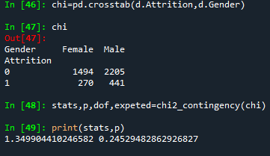

H0: there is no releation ship between gender & attration

H1: there is releation ship between gender & attriation of employee

The p value is grater than 0.05 so H0 is proof

**2. Chisquare test (use to check dependency of variable, variable should be categorical)**

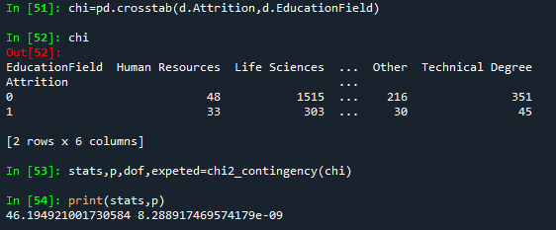

H0: there is no releation ship between in Attriation & education field

Ha: there is releation ship between in Attriation & education field

The p value is less than 0.05 so alternative hypothesis is true

**3. fridman test (compare more than 2 paired variable )**

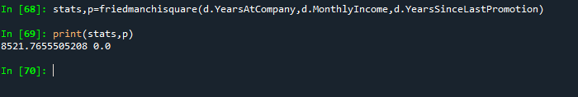

H0: there is no significance relation between how many YearAtCompany ,MonthlyIncome & YearSinceLastPromotion

Ha : : there is significance relation between how many YearAtCompany ,MonthlyIncome & YearSinceLastPromotion

P value is less than 0.05 so Ha is true

**4. Mannwhiney test (compare 2 independent sample )**

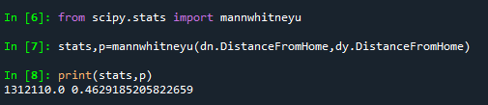

dn=(data set where Attrition is NO)

dy=(data set where Attrition is Yes)

H0: there is no significance between Attrition yes Distance from home to Attrition no Distance from home

H1: there is significance between Attrition yes Distance from home to Attrition no Distance from home

P value is grater than 0.5 so H0 is true